TERRAFORM 5
- . Watch the Terraform-05 video.
- . Execute the script shown in the video.
- Main.tf
- terraform {
- required_providers {
- aws = {
- source = "hashicorp/aws"
- version = "~> 5.0"
- }
- }
- }

- provider "aws" {
- region = "eu-north-1"
- }

- resource "aws_s3_bucket" "s3_bucket" {
- bucket = "my-terraform-bucket-eunorth1-12345" # MUST BE UNIQUE
- }
- Variable.tf
- variable "bucket_name" {
- type = string
- description = "S3 Bucket Name"
- }
- Output.tf
- resource "aws_s3_bucket" "s3_bucket" {
- bucket = var.bucket_name
- }
- Now, in vs code open terninam laddd
- Terraform init,
- Terraform plan
- Terraform apply
- Bucket created in aws

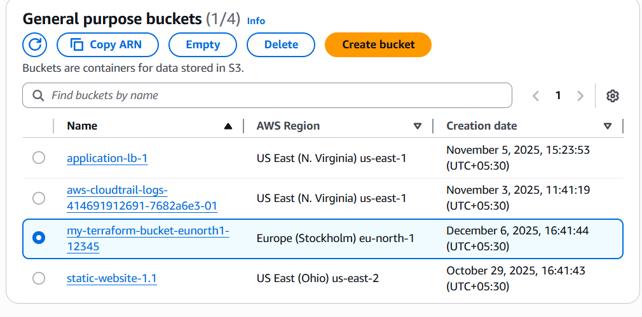
- . Create one EC2 instance with httpd installed using a Terraform script.
- Aws configure
- Main.tf
- Vriable.tf
- Output.tf
- Terraform init and terraform plan a
And terraform apply
Instance will be launched in aws

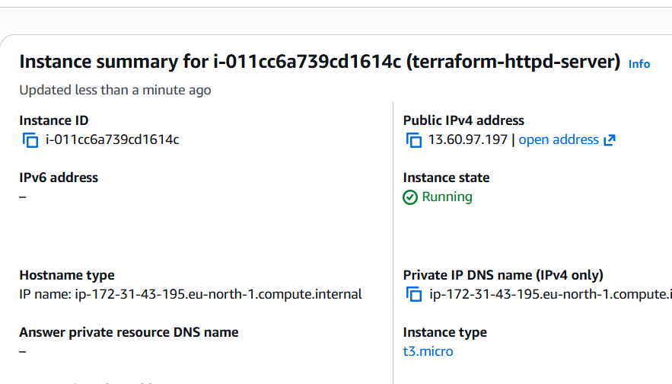

- . Set up S3 as backend for task 3
- Create file .s3.step.tf
- And add script
- provider "aws" {
- region = "eu-north-1"
- }

- resource "aws_s3_bucket" "backend" {
- bucket = "kamal-terraform-backend-2025" # MUST be globally unique
- }

- resource "aws_s3_bucket_versioning" "versioning" {
- bucket = aws_s3_bucket.backend.id

- versioning_configuration {
- status = "Enabled"
- }
- }

- resource "aws_dynamodb_table" "lock" {
- name = "terraform-state-lock"
- billing_mode = "PAY_PER_REQUEST"
- hash_key = "LockID"

- attribute {
- name = "LockID"
- type = "S"
- }
- }

- Run init and apply

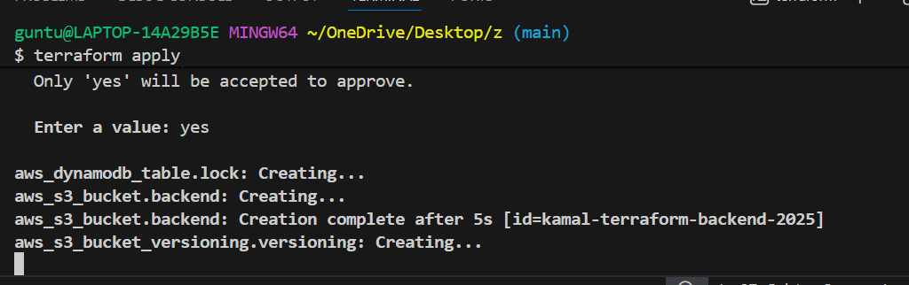

- . et up DynamoDB locking for task 3.
- Create a folder ,
- Add a file called dynamo.db.tf
- Add script
- Openv terminal and run
- Init and apply
